Data Retention and Data Export mechanism in IMC, How it works.

**Labels: HPE Comware Switch**

**Requirement:**

Data Retention mechanism means how long a data should be retained.

Data Export means how often collected data should be exported.

**Solution:**

Settings for both retention and export are under *System > Data Export Settings*

Settings are there for only specific set of folders shown in *System > Data Export Settings*page.

**Configuration:**

**Data Retention**

1. Before change-

We are verifying how changes happen to only one folder(/IMC/client/backup/devAlarmExport).  
Only the oldest, dated 1st of Feb 2016  would be deleted.

We can see that folder backed up at 2AM dated 1st of Feb 2016 is there.

9999 days is the default which is around 27 years ! This means with default retention plan, the oldest file will be stored in IMC for 27 years. Please note here we are concerned about Alarm Exports only, which are saved in imc\client\backup\devAlarmExport. We can change settings for different types of data, depending on the tab we choose.

[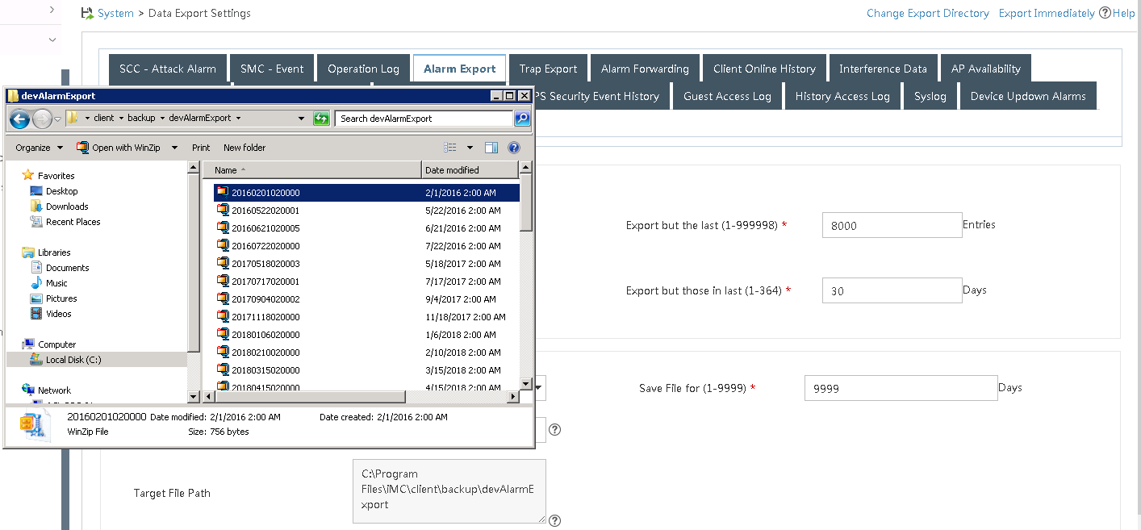](https://akb.arubanetworks.com/media/ckuploads/1110/2021/11/29/before-appyling-change.PNG)

2) Changing from 9999 to 2000 days, covers the date 1st of Feb 2016, **going backwards from the day when it was applied.**(1852 days).

[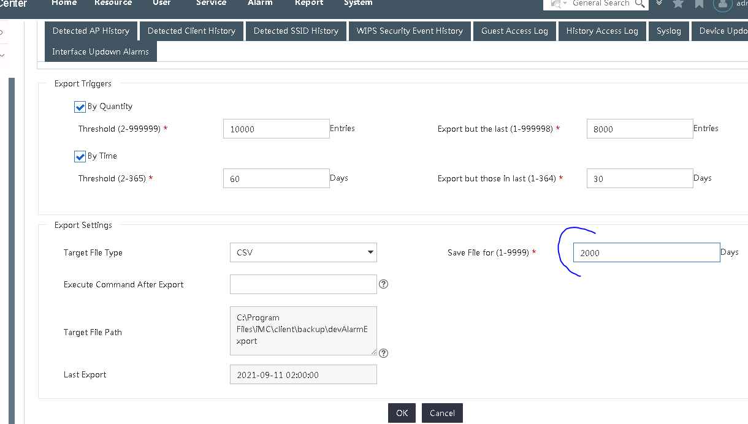](https://akb.arubanetworks.com/media/ckuploads/1110/2021/11/29/changed-the-retention-parameter.PNG)

3) After change-

Every morning at 2AM, IMC performs its auto-backup and other tasks like data retention updation.   
Now we could see that the file is deleted.

[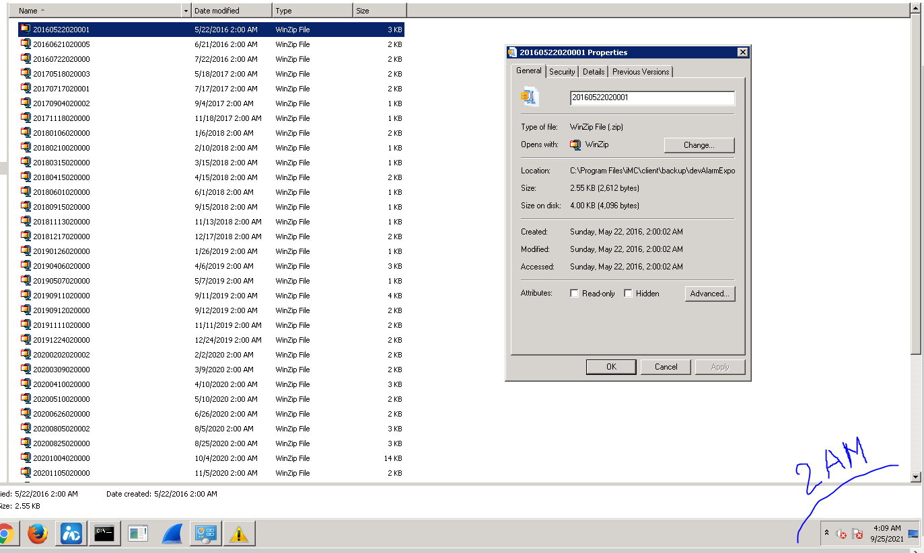](https://akb.arubanetworks.com/media/ckuploads/1110/2021/11/29/after-applying-change-next-day-after-2am.PNG)

**Data export(by Time)**

Data trigger explains

-how often to export and

-how many last days' data not to export.

In below example, we are explaining only the data triggers set by time, not quantity of data.

When both time and quantity is  check-marked, IMC chooses criteria which has more entries.

1. Settings

[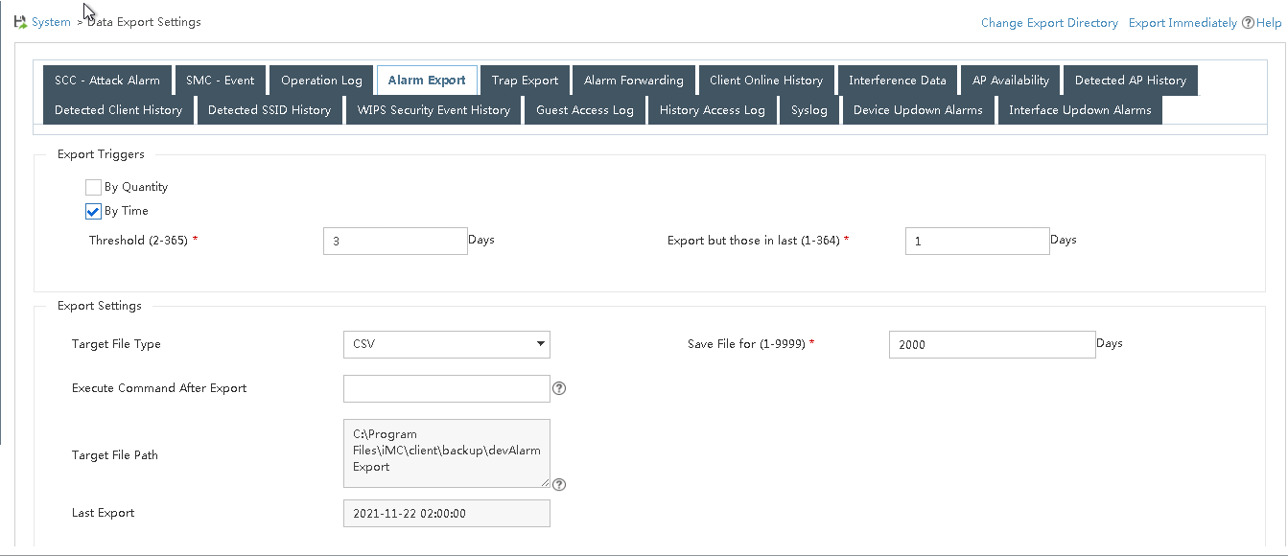](https://akb.arubanetworks.com/media/ckuploads/1110/2021/11/29/export-trigger-settings-for-threee-day-threshold.PNG)

2.Consolidated log file for three days.

[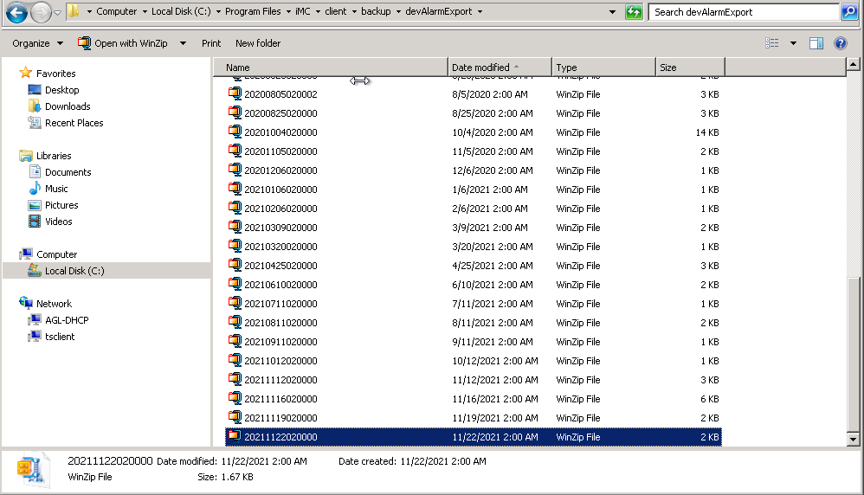](https://akb.arubanetworks.com/media/ckuploads/1110/2021/11/29/exported-files-as-per-three-day-threshold-criteria.PNG)

3.

**Actual logs which were exported on 22nd of November midnight.**  
i.e below days' logs were only exported for the particular settings.  
18-19  
19-20  
20-21

See that 21st to 22nd was not exported, as per *Export but those in last* setting

[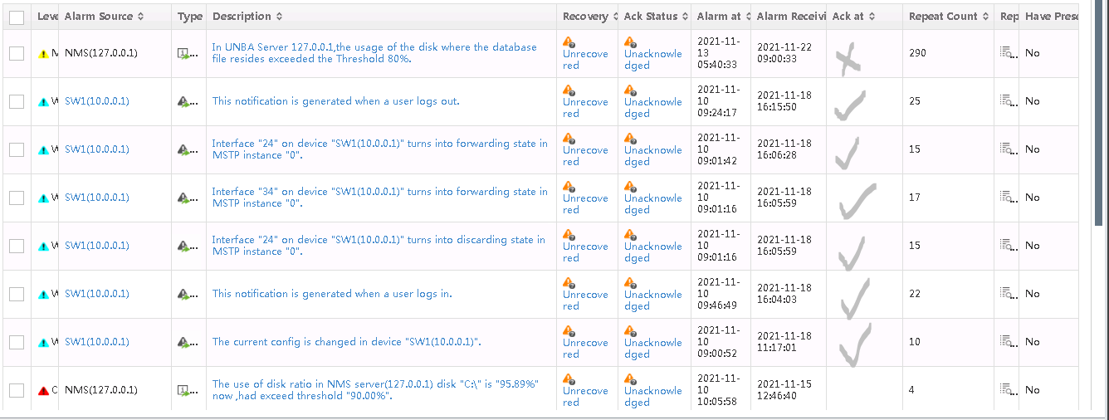](https://akb.arubanetworks.com/media/ckuploads/1110/2021/11/29/all-alarms-actual-exported-logs-for-3-days-threshold.PNG)

**Verification:**

As explained , for verification check back the folders where export is triggered.

Tags: HPE Comware Switch, arubacx-10000-10.09.0010, #imc, data retention, data export